On behalf of America Saves, it is my honor to notify you that your organization has earned the 2022 Savings Champion Award. Your commitment to helping your community build financial resilience and achieve overall financial wellness was evident through your work during America Saves Week. We know that commitment extends beyond the Week into your everyday interactions year round.
The success of America Saves and our programs would not be possible without YOU, partners who are both mission-aligned and take action.
Thanks to your contribution during America Saves Week we impacted the economy in the following way:
2022 Economic Impact Statement:

During America Saves Week 2022, participating organizations reported that individuals deposited $1,134,122,355.56 into new and existing savings accounts over the one week timeframe.

Nearly 415,000 individuals set up a new savings account or made a deposit into an existing savings account. Furthermore, just over 200,000 individuals either set up automatic savings or increased the amount that they save automatically.

Collectively, nearly 3100 participating organizations reached 11.17 million individuals during America Saves Week. Those individuals are now empowered with positive savings messages and resources that help them continue to rebound from the economic effects of the Covid-19 pandemic, supporting their efforts to build financial resiliency.
In the coming days our team will be reaching out to you with additional information regarding your reward, public announcements, press releases, and more. In the meantime we've attached your 2022 America Saves Savings Champions Digital Badge so that you can add to your websites, social channels, and other communications. Congratulations again!

All Good Things,

Kia McCallister-Young
Director | America Saves
An initiative of the Consumer Federation of America
"Empowering Americans to build financial confidence."
Learn about who we are and what we believe here.

LOCAL CAMPAIGN SPOTLIGHT
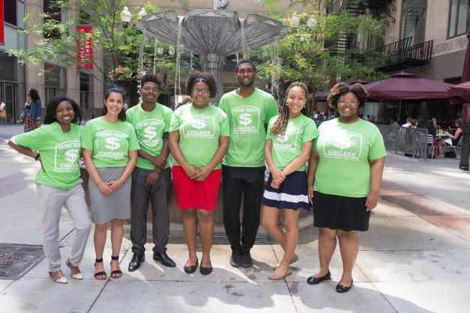
This month we’re happy to spotlight another one of America Saves’ own local campaigns, Illinois Saves. Illinois Saves is a campaign coordinated by the Economic Awareness Council, whose mission is to prepare students and families for the economic and financial decisions they will make both today and tomorrow. Illinois Saves incorporates America Saves messaging into a variety of programs in partnership with Chicago Public School High Schools, the Department of Children and Family Services, and Bank On Chicago.
Illinois Saves engaged another partner, One Summer Chicago, as an America Saves for Young Workers employer. One Summer Chicago is offered in partnership with the City of Chicago, the CFE Fund, and dozens of other valuable partners across the city including After School Matters, Chicago Park District, and other city organizations, nonprofits, and financial institutions. This employment and internship program provides youth with the opportunity to participate in an online financial literacy program that includes the incorporation of the America Saves pledge. With the inclusion of the America Saves for Young Workers initiative, Illinois Saves and One Summer Chicago are working to change how America saves, one young worker at a time.

That’s it for our April Partner Update! Thank you for joining us in our commitment to meet our Savers where they are by providing down-to-earth, and easy-to-implement strategies to support them on their savings journey.

-The America Saves Team

Copyright @America Saves, All right reserved.
Unsubscribe
1620 I ST NW, Suite 200, Washington DC, 20006

