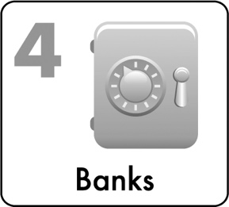

Bank On It

***“Saving has become an easier thing to do. The reason for this is that I have opened a bank account.”* Robert, Chicago Youth Employee**

TERRI’s Story

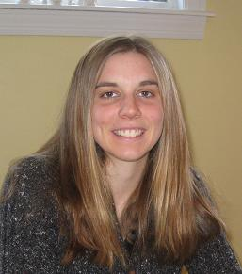Terri had a summer job as a day camp counselor. If Terri earned $2,100 from this first summer job paid in seven $300 checks, how would banking have made a difference for Terri? Check cashing fees on each $300 check would cost about 3% or $9 each on average. This would be $63 Terri would have paid over the summer just to get her own earnings!

*\*Reminder: Complete the Be Pay Day Ready financial education modules at* [*LRNG-OSC.org*](http://www.LRNG.org/Chicago)

What should you Look for when choosing a bank?

1. **FDIC Insurance -** If you are looking for the most SECURE account, do NOT forget to look for an account that is FDIC insured (see page 28 - definition at top).
2. **Low Minimum Balance Requirement -** As a student or young adult, it can be hard to keep a large amount of money in your account. Look for an account with a low minimum balance requirement (i.e. $25 or less).
3. **No or Low Fees -** Fees can add up. Be sure to choose an account that has no or low fees. Look closely at fees a bank may charge for each service you use or things like getting paper statements, age, inactivity or going below your minimum balance.
4. **Opt Out of Overdraft Protection –** Overdraft fees can really add up if you accidently go into the negative in your account. (See pages 33 & 34 for more info.) ASK FOR AN ACCOUNT WITH NO OVERDRAFT!
5. **Convenience/Mobile Banking –** Having a bank that is convenient or has convenient ATM locations can help you to reduce fees. Most young adults prefer to access their account information online or even on their phone. For some, mobile check deposit is a priority. Talk with your banker about these options.
6. **Interest or Incentives -** Some banks offer **interest** or incentives.These are generally small, and free money is good; balance the cost of any fees with the incentives.

BANK ON IT

Many individuals **start banking with a savings account** & **checkless checking** to build their banking experience!

**IMPORTANT: Be sure to limit your withdrawals from your savings. These are limited to 5 or 6 withdrawals per month at ALL banks due to national regulations.**

**Did You Know?**

*If you are looking for a way to keep your money safe, an FDIC insured account may be for you.* ***The FDIC or Federal Depository Insurance Corporation is an independent organization that was founded in 1933 just to protect the funds of bank customers like you.*** *When you go to the bank, talk to the banker about FDIC insured accounts.*

**DEAR DICTIONARY**

**You will need to know each of these terms when opening & using your bank account.**

**Interest** = A small amount of extra money the bank pays you just for keeping your money there

**Custodian** = A responsible adult who jointly owns your account with you if needed

**Signature Card** = A legal document that you sign when opening a bank account – used to show your identity

**Balance (noun) =** The amount of money in your account

**Minimum Balance =** The least amount of money required to be kept in your account to avoid fees

**Minimum Opening Balance =** The least amount of money you can deposit in your account to open it

**Deposit** = To put money IN your bank account

**Withdraw** = To take money OUT of your bank account

*“For savings, my personal advice is… have it separate from your checking account... Make sure that you are at least putting something away each month… discipline yourself that that is your separate emergency savings and that you are not going to draw from that on a regular basis.”*

Debbie, Young Adult



**How do you Open a BANK account?**

**Account Opening Simulation**

*You are getting your first job and you would like to open a bank account so you can safely deposit your earnings and so you can earn extra money in the form of interest. You have $20 to deposit.*

*The application process varies between various banks and financial institutions. We have included some of the basic information that many institutions ask for and the first steps below.*

**OPENING YOUR ACCOUNT**

1. You will need to complete an application form.
2. You will be asked to share information about yourself, which will likely include some or all of the following items: your name, your address, your social security number, your driver’s license or state ID number (or sometimes school ID number), the ID issue date and expiration date, your email, your phone number, your cell phone number, your birth date, etc.
3. You may need to have a custodian (or responsible adult) on your account as a joint owner if you are under 18. (Non-custodial accounts are available at some banks in many states. Shop around if you feel it would be best to have your own account!)
4. You generally will need to **bring your identification* such as your social security card, driver’s license or state ID as required to the bank or financial institution.** (Sometimes a piece of mail is required for proof of address. Some banks may accept the Chicago City Key ID or a Matricula Card and ITIN or a school ID for those under 18. This varies by bank.)
5. You may need to record the amount you will be depositing, and you will need to provide the deposit. In the case of this simulation, $20 is needed.
6. You will need to sign your application. If you are required to have a custodian on your account, your custodian will also need to sign the application.
7. You (and your custodian, if on the account) will need to complete a signature card.
8. Be sure to keep funds in your account to keep your account active and be sure to ask about any specific things you need to do to avoid fees. Keep your banker’s contact information in case you have any follow up questions.

BANK ON IT

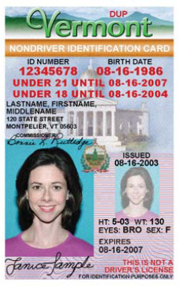

**sample application form (ACTUAL forms will vary)**

**Use this form to practice opening an account. Use the sample information in the State ID at right and social security card below. You may use your name but do NOT use any other identifying or private information on this sample form.**

**Account Number**: 2345678901 (to be completed by bank)

**Account Type**: Savings (to be completed by bank)



|  |  |  |
| --- | --- | --- |
| First: Jane or John | Last: Doe | MI: |
| Address: 120 State St. | City, State: Montpelier, VT | Address Since: _8__ / 2003  mm yyyy |
| Social Security Number:  000-00-0000 | Drivers License #/State ID#: 12345678 | State Issued: Vermont |
| ID Issue Date:__8_ / 16 / 2003  mm dd yyyy | ID Expiration Date: :_8__ / 16 / 2007  mm dd yyyy | Birth Date: 8 / _16__ / 1986  mm dd yyyy |
| Email Address:  *Do not complete for this simulation* | Employer: | Occupation: |
| Employer Address: | Employer State: | Cell Phone:  *Do not complete for this simulation* |
| Business Phone:  *Do not complete for this simulation* | Home Phone:  *Do not complete for this simulation* | Married/Unmarried/Separated |
| Opening Balance  $20.00 | Transfer/Check/Cash  *(What type of funds did you bring for your initial deposit)* | Type of Account:  Savings |

123

Your Signature Date

Joint Owner #1 Signature (Custodian) Date

**JANE OR**

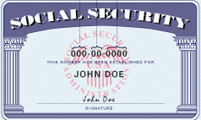

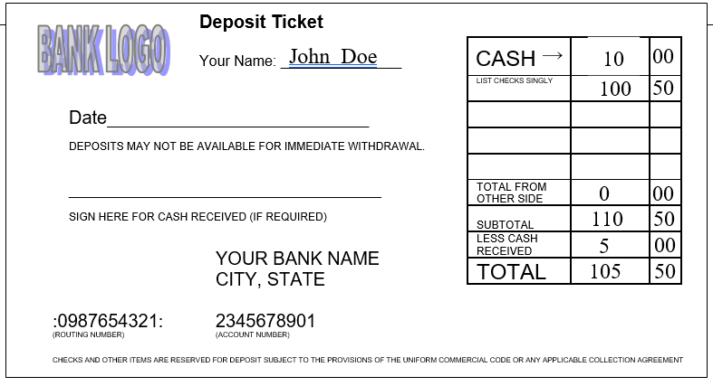

BANK ON IT

BANK LOGO

CASH

→

LIST CHECKS SINGLY

TOTAL FROM

OTHER SIDE

S

UBTOTAL

L

ESS CASH

RECEIVED

TOTAL

$10

00

**Deposit Ticket**

Your Name: _______________



Date__________________________

Deposits may not be available for immediate withdrawal.

_______________________________

Sign here for cash received (if required)

Your bank name

City, State

:0987654321: 2345678901

(Routing Number) (Account Number)

checks and other items are reserved for deposit subject to the provisions of the uniform commercial code or any applicable collection agreement

**How do you MAKE A DEPOSIT AT YOUR BANK?**

**Making a Deposit**

*You are working at your first job. You have both your $100.50 paycheck as well as $10 cash that a friend paid you back to deposit. What do you do?*

* Bring proper identification (state ID/driver’s license or in some cases City Key or Matricula Card).
* Get a form called a **DEPOSIT TICKET or DEPOSIT SLIP**.
* The deposit ticket has a place for your name and account number as well as a place to write the date.
* Fill in the date, your name and your account number (#2345678901 for now).
* Now, look for a table on the slip where you would record the amount you are depositing.
* Remember - you had $10 cash and a $100.50 paycheck to deposit.
* Write in that you have $10.00 in cash. (This goes just to the right of where *“Cash”* is listed. Notice that there is a wide column for dollars and a skinny column for cents.)
* Now, write the $100.50 amount in the column to the right of where it says *“List Checks Singly”* & $0.00 where it says “*Totals from the Other Side*”.
* Now, add up your subtotal: $10.00 + $100.50 + $0.00 = $_110.50__
* Next, let’s say you would like $5 back in cash. Write in the $5 cash back in the correct location – this would go to the right of *“Less Cash Received”.*
* Subtract $5 from *Subtotal* to get your *Total*. This is the amount you will deposit and should be $__105.50________.
* Provide the bank teller with your deposit ticket, check, cash and your ID.
* The teller will provide you with a receipt.

**How do you MAKE A withdrawal AT YOUR BANK?**

**Making a Withdrawal**

*You need $20 now to pay a fee at school.*

*What do you do? How can you get money out of your account?*

1. Get a form called a **WITHDRAWALTICKET OR SLIP**.
2. Fill in the date, your name, address and account number (from below).
3. Record the amount you would like to withdraw, $20.00, both written out (Twenty & 00/100) on the line below as noted and as a number ($20.00) in the box with the $ symbol. (Do not leave extra space.)
4. Sign the withdrawal slip where “signature” is noted.
5. Bring proper identification as you will be asked to share this.
6. Always complete all information clearly and in ink.

Date & Account #

**Check out this sample savings account statement!**

$ 20.00

Customer Name: John Doe

Customer Address: ______120 State St. Montpelier, VT_____________________

Twenty dollars and 00/100 cents

**John Doe**

Signature

Account 1234567890

Date: _____________________

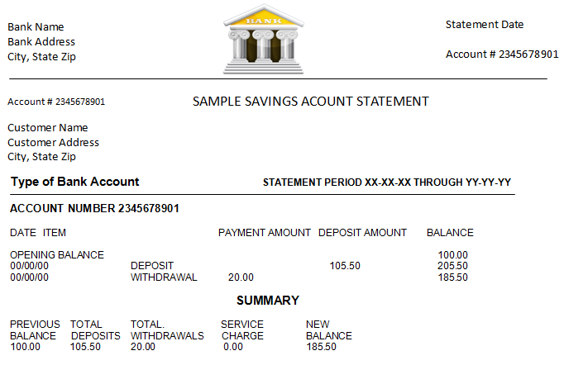

BANK LOGO

Bank Address

City, State

Deduct above sum from my savings account

withdrawal

**Final amount of $**

Amount of $ after withdraw

Amount of $ after deposit

Amount of $ at beginning of time period

Dates that begin and end the time period of the statement

Identifying Information

CHECKLESS CHECKING

Most youth choose to eventually open a checkless checking account, even if they started with a savings account. A checkless checking account allows youth to make payments with a debit card and online as well as via apps on your phone.

Checking is a BIG responsibility. Be sure to ask for checkless checking with NO OVERDRAFT and KEEP YOUR ACCOUNT POSITIVE*!

*Think about starting out with a [student] checking account because it is free and you don’t have to pay a lot of the fees that people usually pay.*

Christie, Young Adult

**what does it mean to balance your checking account?**

Your bank account has both DEPOSITS (or money that comes into your account) and WITHRDRAWALS or PAYMENTS (money that goes out of your account). With any bank account, the money going IN to the account must be EQUAL or GREATER than the money going out. If not, your account will go NEGATIVE or have non-sufficient funds. This is bad because you will be charged a fee and must pay the bank back the funds you borrow PLUS the fees. See the mobile banking tips on page 36 to keep track of your spending to keep your account POSITIVE.

If you choose an account with NO OVERDRAFT, your bank will decline purchases if you do not have enough funds to pay for them. *For example, if Mary wanted to buy a coat that was $50 but she only had $25 in her account, Mary’s NO OVERDRAFT bank account would decline the purchase. Mary won’t get the jacket, but she would save herself a big fee!*

**Watch out for automatic, online charges like subscriptions, Netflix, Hulu, gym fees, etc. Even with an account with no overdraft, the bank will not be able to stop these charges.**

**\*Keep a positive balance – meaning keep money in the account.**

BANK ON IT

***“It is very important to have a [checking account] and it’s very important to keep money in there.*** *While I was at college, you know you overspend and sometimes you write a check and you don’t have the money, you know non-sufficient funds. You definitely don’t want to do that because …they are reporting that across the board… to the point where you may go out and you might not be able to write another check or you might be denied for something simply because you are not keeping up with your checking account.*

***It’s very important to keep a positive [balance], meaning money, in your checking account.”*** Tamika, Young Adult

**DEAR DICTIONARY**

**Non-sufficient funds** = when the funds in your bank account do not cover the amount of a charge (check, debit card transaction, etc.)

**Overdraft Protection** = a service in which a financial [institution](http://www.investorwords.com/2501/institution.html) loans you money in the case that you have non-sufficient funds. However, you will have to pay the loan back plus fees. **Opt out of overdraft protection to avoid fees!**

**Average overdraft or non-sufficient funds (NSF) fees are $27-$30! (you may be charged Even if you just spend a few DOllars!) KEEP YOUR ACCOUNT BALANCED!**

**LEAVING A BANK ACCOUNT WITH FUNDS OWED CAN LEAD TO BEING PLACED ON ChexSYSTEMS. ThIS MAY PREVENT YOU FROM BEING ABLE TO EASILY BANK AGAIN. BE SURE TO KEEP YOUR ACCOUNT BALANCED!**

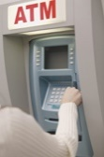

**Dear dictionary: balancing definitions**

BANK ON IT

**to balance** = to match the bank activities in your records (checks written, deposits, withdrawals, fees, etc.) with the activities in your monthly statement

**to overdraw or to bounce a check** = to write a check or make a payment when there is not enough money in your checking account to cover the check or payment (Also refered to as having non-sufficient funds (nsf))

**check register** = THE FORM INCLUDED IN YOUR CHECK BOOK WHERE YOU CAN RECORD ALL OF YOUR ACCOUNT ACTIVITY

Some people record their transactions in a check register or notebook while others prefer to use their app. This is fine but be sure to leave a BUFFER of funds and consider any transactions that might be **pending** or might not appear on your online account yet. See sample check register below or use a simple list of payments (and withdrawals) and deposits to balance your account on paper if desired.

|  |  |  |  |  |  |  |  |  |  |  |  |  |
| --- | --- | --- | --- | --- | --- | --- | --- | --- | --- | --- | --- | --- |
| **SAMPLE CHECK REGISTER**  Record All Charges or Credits that Affect Your Account | | | | | | | | | | | | |
| Number | Date |  | Description of Transaction |  | Payment/Debt | √ | Fee (If Any) |  | Deposit/Credit |  | Balance | |
| $ 100 | 00 |
|  |  |  | $ |  |  | $ |  |  |
|  |  |  |  |  |  |  |  |  |

Some people record their transactions in a check register or notebook while others prefer to use their app. This is fine but be sure to leave a BUFFER of funds and consider any transactions that might be **pending** or might not appear on your online account yet. See sample check register below or use a simple list of payments (and withdrawals) and deposits to balance your account on paper if desired.

**Writing a Check**

Although checkless checking is recommended for your first account, at some point you may need to add checks to your account or write a check. Be very careful with writing checks to ensure that you have enough funds in your account to cover the cost of the check BEFORE you write it and until it is cashed.

1. Writing a check is very simple. First, let’s review what information is on the check. There is a place where your name, your account number and the bank’s transit number will be printed so that they can find your account.
2. There are also several blanks for you to complete. There is a blank for the date – please fill this in with today’s date.
3. Next, there is a blank that says “*Pay to the Order of*” – this is where you write down who you are paying. Let’s say you are paying “*Cellular Company*”. Write “*Cellular Company*” in the line next to the words “*Pay to the Order of*”
4. Next, find a blank rectangle with a dollar sign. This is where you write the amount of your check. Let’s say you owe the *“Cellular Company”* $20.35. Write in this amount using numbers.
5. Now, find a blank line with the WORD *“Dollars”.* This is where you write your amount in words so there is no confusion about the amount due to handwriting. (Write $20.35 using words.) Many people write this as *“Twenty”* and then the number 35 over 100 for cents (or hundredths of a dollar). This looks like *Twenty & 35/100* .
6. Next, there is a blank for you to write a note to help you remember what the check was for to the right of the word *“For”.* Write *“May Bill”* on this line.
7. Lastly, there is a blank space for you to write your signature just like when you endorsed the check. Sign your name on this line (near the bottom right of the check).
8. Now, you are not done yet. Where would you need to record this check? That is right. You need to record this on your check register.

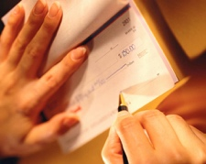USE THE SAMPLE CHECK BELOW TO PRACTICE WRITING A CHECK AS INSTRUCTED ON THE PREVIOUS PAGE.

BANK ON IT

Your Name 0123(Check #)

Your Address

Your City, State, Zip Code 1234567890 (Acct #)

*Date____Today______*

*Pay to the Order of Cellular Company*

*___Twenty Dollars and 35/100 ___________________________________Dollars*

*YOUR BANK NAME*

*CITY, STATE ZIP*

*PHONE NUMBER*

*For_May Bill _____ ____***Your Signature***_________________*

:123456789: 1234567890 0123

(Routing Number) (Account Number) (CHECK NUMBER)

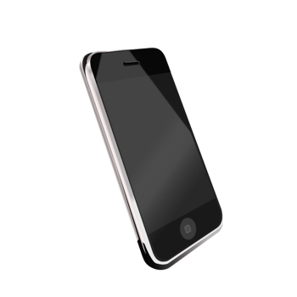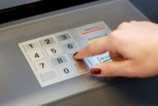

**PAY ATTENTION & ONLY USE ATMS THAT ARE IN-NETWORK TO AVOID FEES!**

**MOBILE BANKING TIPS**

Many young adults prefer to use mobile banking for many of their transactions.

1. Be sure to **track any mobile or ATM transactions**.
2. Keep your account information & **passwords secure and private**.
3. **Mobile check deposit** is an efficient, safe and secure way to deposit a check from your employer without having to leave your home. BUT remember **once a check is deposited via mobile deposit, you cannot cash or deposit it again**. Write DEPOSITED on the check so there is no confusion. You will not be able to fool anyone. This is fraud.
4. **Do NOT cash or deposit checks from sources you do not trust in person, via ATM or via mobile deposit. You will get caught if the check is fraudulent and may be banned from banking. This is a crime.**
5. Be cautious when downloading apps, sending money or making payments online. Look for sites that are secure and check your transactions on your banking account daily to catch any fraud.
6. Set up text alerts for transactions on your account or if your balance gets low. Check your balance daily!

Visit LRNG-OSC.org – Be Pay Day Ready for more tips on mobile banking & see Chapter 8 Identity Protection for more tips on account security.

$20.35

**Consider Account Safety TIPS:**

1. Keep all important personal identification, bank documents, passwords & account information private and secure.
2. If you have a **debit card, keep your Pin private & MAKE SURE IT IS not obvious to others.** *(ie. not your birthday*).

* If you share your pin, you will be giving others access to all of your funds.

1. **Do not store your PIN # with your debit card!**
2. **ONLY ACCEPT CHECKS OR FUNDS FROM TRUSTED SOURCES!**

Check your account frequently for any suspicious transactions and report any problems to your bank immediately. **SEE PAGE 59 FOR MORE INFORMATION!**

bank jeopardy: check out what you know!

Let’s see how much you have learned! **Complete this Bank On It Jeopardy review below by filling in the blanks with the appropriate term from Ch 4.**

* Question: When you put money into your checking account, this is called making a d_ _ _ _ _ _.

eposit

* Question: When you take money out of your bank account, this is called making a w_ _ _ _ _ _ _ _ _.

oan

ithdrawl

* Question: I_ _ _ _ _ _ _ is a small amount of extra money the bank gives you just for keeping your money in your savings account.

ee

BANK ON IT

* Question: Some banks charge no or low f_ _ _ and you can open an account with as little as $25 or less.
* Question: If you write a check and do not have enough money in your checking account, this is called bouncing a check or o_ _ _ _ _ _ _ _ _ _ your account.

DIC

verdraw

* Question: Even if your bank goes out of business, money in an F_ _ _ insured account is protected, and you will not lose any of your funds.

**Ask your instructor about the process of selecting a bank as well as how to find local banks with high quality accounts.**