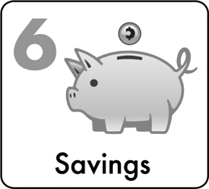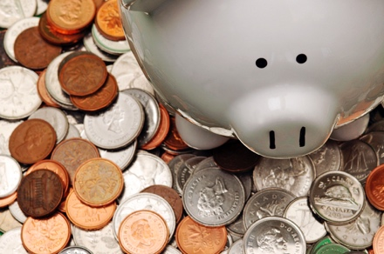

2

Wealth Builder:

Saving & Investing

***” Emergency funds are necessary. You have to keep your little side thing. You never know when something might happen …”***

*Walter, Graduate Student/Social Entrepreneur*

emergency Savings: Crystal’s story

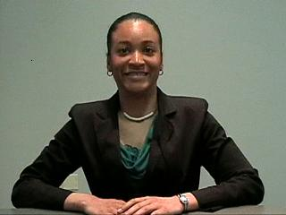Crystal went to college in an urban area that had a lot of crime. In Crystal’s first year of college, her car was broken into 6 times. Because of this, Crystal had over $1,000 in surprise expenses. **Who has $1,000 in their budget to pay for extra expenses!?** These expenses drove Crystal into credit card debt and cost her hundreds of dollars in interest charges. But what if Crystal had had an emergency savings account?

**If Crystal had had an emergency savings account, she would have been able to pay for all her repairs out of this account.** This would have saved her hundreds of dollars in credit card fees and interest and a lot of headache and worry!

WEALTH BUILDERS

***“I found out that saving was going to save me!”***

Crystal, College Senior in Need of Emergency Savings

**Emergency savings should be priority #1 for most young adults!**

**Emergency savings can save you hundreds of dollars in interest charges for credit card costs or pay day loans!**



**Emergency savings should be a first saving priority.**

**How do you start an emergency savings account?**

1. **Start by setting aside whatever money you can for your emergency savings account.**

* *By the time you are a working professional,* ***experts recommend that you set aside 3 to 6 months of BASIC living expenses*** *(just the essentials).*

1. Deposit your emergency savings in an account that is **SAFE**. A regular savings account that has no fees AND is FDIC insured (see p. 28) is a good option as this means this insurance will protect YOUR funds.
2. Don’t forget … this account is just for EMERGENCIES. **If you withdraw money from your account for an urgent expense, REPLACE it as soon as possible**. You may want to have a **separate** savings account for specific **short-term goals** as well.
3. Use summer job $, gifts, and/or some of your earnings from each paycheck to build this account BEFORE you are on your own. Use direct deposit to save automatically.

**Certificate of Deposit** = Some youth choose to save their funds in another insured account product called a CD (Certificate of Deposit). With a CD, you promise to keep funds in an account for a set period of time (6 months, 1 year, etc.) and often earn more interest. A CD can also help you avoid being tempted to spend your funds, but be aware that there are fees if you withdraw your funds early.

EMERGENCY SAVINGS

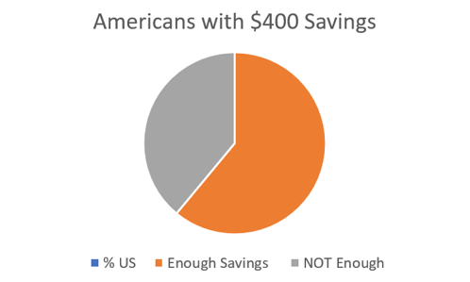****

How many people have enough emergency savings?

**39% of individuals do NOT have enough savings to cover a $400 expense!**

[(Federal Reserve Board of Governors, 2019)](https://www.federalreserve.gov/newsevents/pressreleases/other20190523b.htm)



***Another real-world story …***

Why does having emergency savings matter? Let’s check out a real-world story… Beth and Bob were young, working adults. They just had a baby. They had car payments and other bills to pay. About 5 months after they started working, Bob learned that he may get laid off. Because Bob and Beth set aside money for emergencies, they knew this money would get them through for a few months if Bob had to look for new work. **ALL young adults should be prepared with EMERGENCY SAVINGS!**

**What is the #1 SAVINGS GOAL for youth?**

**EMERGENCY SAVINGS!**

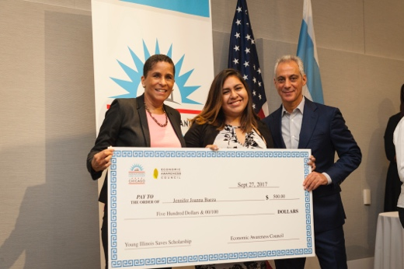*“My main tip that I have learned is to put 20% to 30% of your check into your savings because that is money that can be used in the future for any emergency or rainy day. This summer I was in a car accident heading to work. If it wasn't for my savings, I would have not been able to do anything at that moment. I was able to fix my car and pay for the hospital bills. It all turned out well in the end because I started saving at a young age.”*

**DEAR DICTIONARY\***

**INTEREST** = a small amount of money that you receive from a bank or financial institution in return for keeping your money in a bank account or other savings vehicle

**Principal** = refers to the original $ invested or in this case deposited

**Deposits** = refer to additional monthly deposits into your savings account

*Definitions for compound interest chart below.

Jennifer, Youth Employee with Former Chicago Mayor Emanuel

Jennifer, College Student & Youth Employee

How does starting early help you to save? **When you save your money, you often earn extra money called INTEREST.**

What does this have to do with saving early? When you earn interest, you not only earn interest on the original amount of money you saved, BUT you also earn interest on any interest you earn. This is called **COMPOUND INTEREST.** Because of this, your money will grow and grow.

Let’s try an example. Let’s say a youth sets aside a portion of their transition fund, $600, in an account earning 1.5% APR compounded monthly. Additionally, the youth sets up direct deposit of $100 from their paycheck every month into the account. In 10 years, the youth will have $13,625, including over $1,035 extra in interest their money will have earned. Calculate your potential savings at Investor.gov.

WEALTH BUILDERS

**Compound Interest Example**

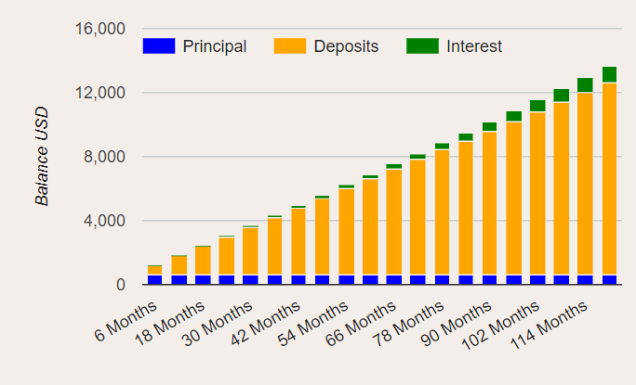**TRY IT: MAKE A PLAN!**

**How will YOU build emergency savings?**



Learn more at helpfulcalculators.com

What should I do after I have enough emergency saving? begin to INVEST for the long-term!

***“If I can do it, anyone can. No money is too little. You can start with $10 a month. Everybody can scrape up $10 a month.”***

Damon, FORMER CHICAGO PUBLIC SCHOOL STUDENT, MONEY SMART KID, YOUNG INVESTOR & COLLEGE GRADUATE

**WHAT IS INVESTING? Investing = using your money to make more money**

After building emergency savings, what else can I do TODAY to help me build wealth for the future? INVEST!

Investing is especially important because of inflation.

**Inflation** = the increase in prices over time. If there is inflation, each dollar you have saved will buy less in the future. After saving, when thinking for the long-term, it is important to consider investing to try to have enough funds to keep up with inflation.

**STEPS TO INVESTING SUCCESS**

**1) Invest in your EDUCATION! Along with emergency savings, EDUCATION should be a top savings & investing priority for young adults! Let’s see why!**

In Chapter 1, you learned about just how much education increases your earning power. How does your earning power help you build wealth?

Let’s look at 2 sample investors. Investor A earns $25,000 per year and works for 40 years investing 10% of their salary. Investor B obtains an associate’s degree and earns $35,000 per year and also invests 10% over 40 years. **The $10,000 increase in annual earnings results in an increase of $500,000 in the total investment value for Investor B after 40 years**. (See chart below.)

*Uses same assumptions for investment return, years worked and salary growth. Both earnings listed refer to take home pay.

INVESTING





After building emergency saving & investing in my education, what can I do NEXT to help me build wealth & financial security for the future?

**2) LEARN MORE about investing!**

Beyond saving your money, there are several types of investments that you can consider. A few of the most common investments are stocks and bonds.

**What are stocks and bonds?**

Let’s say that you had a growing company and the company needs more funds. How could the company get those funds?

1. **Stocks** = An investment that means part ownership of a company

Your company could sell part of the ownership of the company (stocks) to get the funds.

1. **Bonds** = An investment in which an investor loans money to a company or the government for a set time period and a set return (or interest rate) and the company or government is obligated or required to pay it back.

Your company could generate funds through bond sales (similar to getting a loan).

Investors must consider investment **RISK** when selecting investments like stocks & bonds.

**RISK** = the chance your investment may make LESS money than you expect. You could even LOSE money!

Often investors have to balance investment **RISK** with the chance for **RETURN**.

**RETURN** = the money you make on your investment

Typically, investments with greater RISK also have a greater potential or possible return BUT this does NOT mean you will be guaranteed to have a greater return, AND there is a greater risk that you could LOSE your money.

**RISK =**  **POTENTIAL RETURN**

EXAMPLE: Think about it this way … In the example above, if your company goes out of business, who do you think is more likely to get paid back or will get paid first - the stock holder (or part owner) or the person that has a bond or obligation that your company will pay them back? – Answer: The bond holder. This reduces their RISK. BUT… If the company doubles its value, which person will get a higher return because of it? Answer: The stockholder who owns part of the company. The bond holder gets paid a fixed amount of interest but if the value of the stock greatly increases, the stockholder has more POTENTIAL RETURN!

WEALTH BUILDERS

How can investors reduce risk?

**Learn about products like MUTUAL FUNDS to DIVERSIFY & REDUCE RISK.**

* **DIVERSIFY = to obtain a mix of investments to reduce risk.**
* **MUTUAL FUND = an investment that pools individuals’ funds together to buy a group or collection of stocks or bonds**
* **INDEX FUND = A group of stocks meeting selected criteria** (ie. Standard & Poors 500 or S&P 500)

**DIVERSIFY to reduce your risk!**

**Real world Example**

**How does a mutual fund help to reduce risk? Imagine a farmer that just grows apples. If there is a disease that hits apples, the farmer loses everything. This is like investing all of your funds into ONE stock.**

**NOW let’s imagine another farmer that, instead of growing just apples, grows a variety of fruit – apples, pears, peaches, and grapes. What if the same apple killing disease hits? The farmer will still have grapes, pears, peaches, etc. This is like diversifying and investing in mutual funds.**

A **mutual fund** reduces risk (IN COMPARISION TO INVESTING ALL FUNDS IN A SINGLE STOCK) BECAUSE If one of the stocks in your fund loses value, you still have the rest of the stocks that may perform well.

INVESTING

**WHICH HAS MORE RISK? Investing just in a single stock or investing in a mutual fund? __________**



= single stock = mutual fund



Be sure to have emergency savings **BEFORE** you begin investing! Also, thoroughly research any investment advisors. Learn more and check the registration & background of your advisor at the **Illinois Securities Department and FINRA’s Broker Check websites** (see Resource List). Carefully consider any fees & the level of investment risk.



**3) Once you begin working, SAVE & INVEST EARLY!**

**Depending upon their return, investments can also grow over time.**

**The Race to Save**

Check it out: If you look at an example of two women, **one who invests about $100 per month* starting at age 21 and the other who invests twice this much – over $200 per month – starting at age 31, who will end up with more money at age 65?**

**The woman that started at age 21 had more money in the end!**

*D*





*“The younger you are, the better. Time is on your side.”* Damon, Chicago High School Student & Teen Investor

**

**\*Assumes investments of $4 per day for the 21-year-old and $8 per day for the 31 year old earning 7% APR.**

**4) Start planning by asking your employer about any investing or retirement planning** options that they provide.

* Consider retirement benefits when comparing different job offers.
* Be sure to take advantage of any incentives like an **employer match,** if available!
* In Illinois, many employers offer access to **Secure Choice**, a state sponsored retirement plan. Learn more about this Roth IRA at ilsecurechoice.com.
* Sometimes companies will have a person or an agency whom you can ask questions about investing. This is a great place to start!

**5) If your employer does not offer any options for investing for retirement,** **seek out a qualified professional that you can trust**. While it may be too expensive to hire an investment advisor right now, **ask your banker** that you know & trust about investing options at your bank. Many banks offer options for investing for retirement, and your banker may be able to help point you in the right direction. Also, check out Free Financial Planning Days & Financial Planning Week – visit FPAIllinois.org.

**Employer Match** = money your employer **gives** you as a contribution or deposit in your retirement account as a percentage of the money that you set aside (ex. you invest $1 in your retirement account & they GIVE you $1 more) up to a certain cap – Yes, this is free money!

WEALTH BUILDERS

1. JUSTINE

*****“[Investing] gives me a sense of security … a different outlook on life … I see people scraping by and living paycheck to paycheck … but now I have an understanding that is not what I want to do … I am trying to build wealth and that is something that everyone should strive to do.”***

(Damon– Former Chicago Money Smart Kid)

**6) Consider TARGET DATE FUNDS. Think about how LONG you have until you need to use the money you are investing and how much INVESTMENT RISK you can handle.** (Generally, if you have a longer time period to invest, most experts say you can consider taking on investments with a higher level of risk.) TARGET DATE FUNDS are funds that automatically determine your investment mix (or asset allocation) to consider risk and the date you plan to retire. (Target date funds are also sometimes called lifecycle funds.)



TIME HORIZON – TARGET DATE FUNDS – INVESTMENT RISK ACTIVITY

Let’s try an example to consider how investment risk may be considered with your time horizon and why target dates funds may be useful. This example uses REAL HISTORICAL data & amounts!

***Wealth Builder: Example 1***

Let’s look at a real-world example… it is 1991…

You have $100 to save or invest for college. You do not need this money for 10 years. Where should you put this money? In a CD earning 4.5% APR GUARANTEED or in the stock market (through an Index Fund (see page 14 for a definition). The stock market has earned 9.5% APR on average between 1981 and 1991, but the earnings are not guaranteed.

Make a choice and circle it.

**A) CD B) Stock Market Index Fund**

***Wealth Builder: Example 2***

It is now 1999 …

You still have $100 to save or invest BUT now you need this money back in 2 years. Where should you put this money? In a CD earning 4.5% APR GUARANTEED or in the stock market which earned 19% last year? But, you can’t afford to lose more than 5%.

Make a choice and circle it.

**A) CD B) Stock Market Index Fund**

INVESTING

**CD or Certificate of Deposit** = A deposit or savings account that is held for a set period of time (often at a higher interest rate than a savings account, but you lose some interest if you withdraw early).

SAVING AND INVESTING

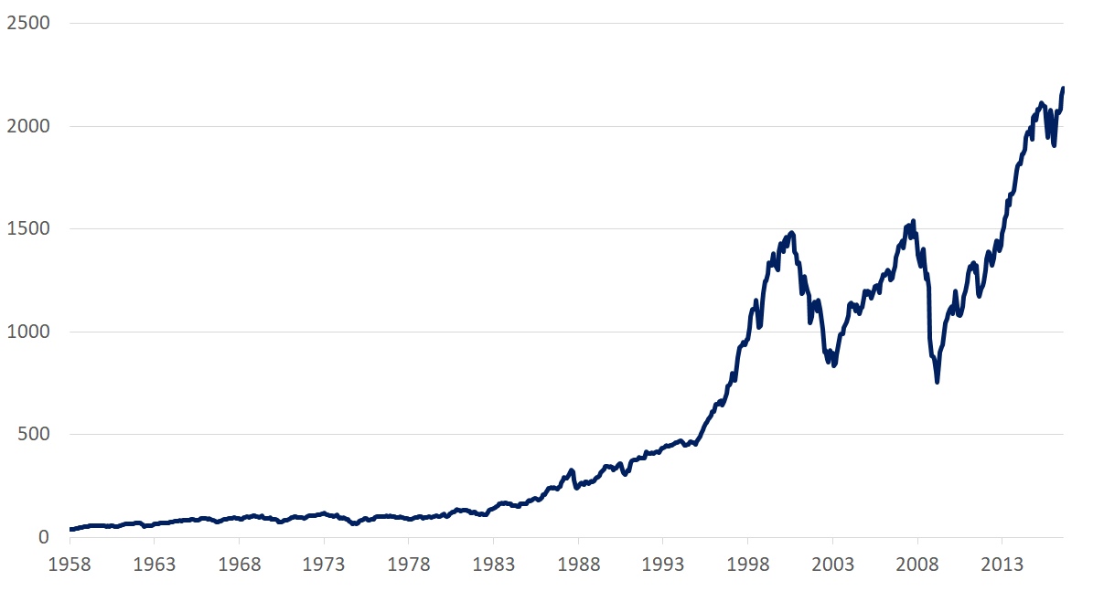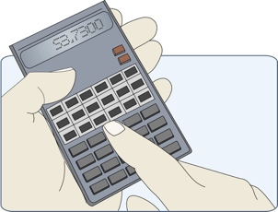

***wealth builder Example 1 & 2 Answers***

How much money did you make?

Fill in the blanks below with your instructor to find out your results (AFTER you have made your selections for examples 1 & 2)!

**CD OnLY (Example 1 A & Example 2 A) = $55 in earnings**

**Stock index only (Example 1 B & example 2 b) = $217 in earnings**

**CD and stock (example 1 a & example 2 b) = $24 in earnings**

**stock & cd (example 1 b & example 2 a) = $297 in earnings**

**Everyone made money - SAVING AND INVESTING PAYS!** But … you can see, in this example, the **people that invested in the stock market early, when they could wait for it to go up or down before they sold or needed the money, earned the most.** **WHY?**

WEALTH BUILDERS

BUT returns are NOT guaranteed! Look at the loss in value around 2000 (17%!) – right when YOU needed the money! **For the SHORT- TERM, consider saving in an FDIC insured account!**

Look at the increase in the value of stocks (the S&P 500) from 1958 to 2015 (over 7% APR on average)!

**People who have had a LONG time to wait out the times when stocks have lost value have made money historically!**

**7) Seek out investments with TAX BENEFITS!**

When you are saving for your future or for the long-term – retirement, college, etc. - be sure to **look for investments that have TAX benefits**.

Why does this matter? Check it out!

If you contribute $200 per month to a Roth IRA (an investment vehicle with tax benefits – see below) for 40 years, you would have over $750,000 in earnings at a 7% APR. Because these earnings are NOT taxed in a Roth IRA, this saves you money - about $188,839* in taxes compared to investments with no tax benefits!

*\* Assuming you are in a 25% tax bracket.*

For example, here are 2 types of retirement accounts with tax benefits:

**Roth IRA** = a retirement account in which your EARNINGS are not taxed (this allows for withdrawals without penalties but there are limits on income)

**IRA/401-K** = a retirement account that allows you to invest with PRE-TAX dollars

**DON’T FORGET TO CONSIDER MUTUAL FUNDS TO DIVERSIFY & REDUCE YOUR RISK!**





***“Usually when you get a job they will say do you want to make any contributions to your 401k, and you may just want to wash it away but don’t be scared to ask questions, ask your other co-workers what do you put in there and they’ll give you advice.”***

INVESTING

Youth in Care & Countdown to 21 Graduate

**8)** **Be sure to consider all FEES and the MINIMUM BALANCE or requirements for direct deposit when considering investment options.** There are options available with no or low minimums! The more you can reduce your fees, the more money you will have to grow your investments!

**9)** **KEEP SAVING & INVESTING!** Once you have set up your investments, remember these funds are for the **LONG-TERM**! Try not to borrow or withdraw from your long-term investment funds. You may have penalties and you will decrease the amount of funds you will have when you retire! **Use direct deposit** to fund your investments automatically each pay period and KEEP SAVING!

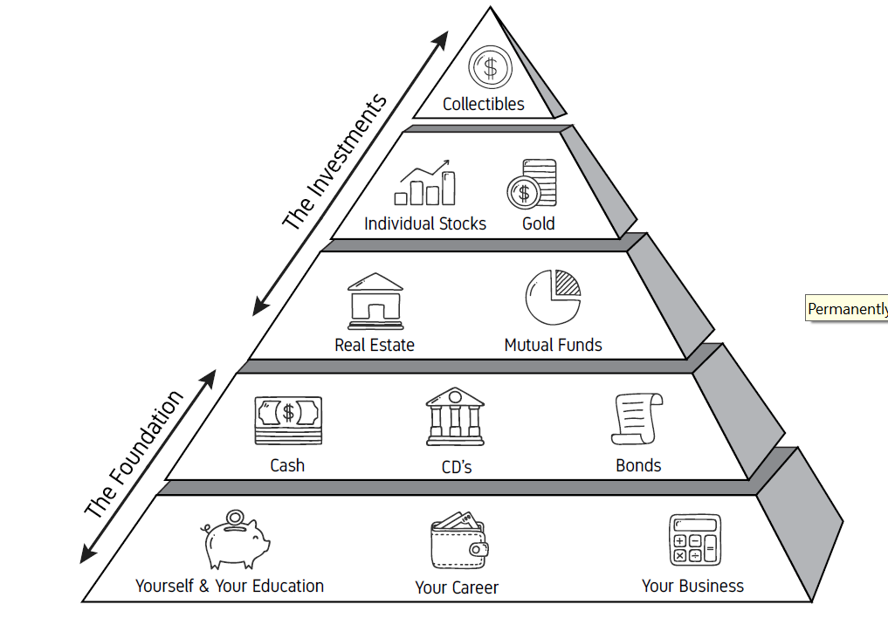

**Investing Pyramid:**

Where do most investors start investing? Review this investing pyramid highlighting the ways in which many people build their investments, focusing on emergency savings & careers at first and then moving to adding more investments over time – after building that secure base. Why is this? How does this relate to risk, potential return & diversification?

**INVESTING**

**RECAP ACTIVITY**

SAVING & INVESTING jeopardy

mergency

* Question: Starting an e_ _ _ _ _ _ _ _ savings account equal to at least 3 to 6 months basic living expenses is a good first saving step for young adults.
* Question: When you save money in a bank, the bank will give you extra money called i _ _ _ _ _ _ _. Save EARLY to earn MORE i _ _ _ _ _ _ _!

und

utual

nterest

nterest

* Question: A stock m_ _ _ _ _ f _ _ _ is an investment that pools funds to buy a group of stocks. A m_ _ _ _ _ f _ _ _ helps diversify your investment to reduce risk and generally provides a s_ _ _ _ return than a s_ _ _ _ _ s_ _ _ _.

isk

tock

ingle

afer

und

utual

* ****Question: When investing, r _ _ _ is the chance that your investment may make less money than planned or that you may even lose money.

tock

* A s_ _ _ _ is a financial tool that represents part ownership of a company.

WEALTH BUILDERS

**REMEMBER … you are working, learning, earning, saving and investing for the LONG TERM. You have many years to build wealth if you start today & don’t give up.**

***“It’s OK to fail, but you can’t quit and most importantly you can’t quit on yourself…*** *Baby steps count, as long as you are going forward. You add them all up, and one day you look back and you’ll be surprised at where you might get to.”* Chris Gardner: Self-made multi-millionaire who experienced domestic violence and was a youth in care as a child, was formerly homeless, the single father of one son and the subject of the movie *“The Pursuit of Happiness”.* Columbia Pictures, 2006.