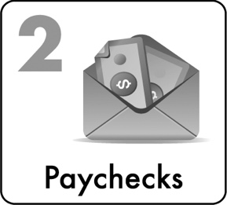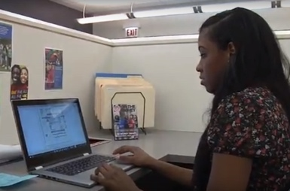

3

Your First Paycheck

***“When I first got my first paycheck, I was just like … wow, you know? I was doing honest grown folk work and getting paid for it. That meant so much to me.”***

*Walter, Graduate Student/Social Entrepreneur*

what is a paycheck?

**What is a paycheck?**

**Paycheck Term Choices**

Employee Name

Employer Name/Address

Date

Amount

Routing/Bank Transit ABA Number

Account Number

**Like any other check, a paycheck is a contract.** It is a promise from your employer that you will be able to get your pay, in the amount that they write down on the check, from your employer’s bank account. **Your check may eventually expire so be sure to deposit or cash your check and of course keep your check in a safe place until it is deposited or cashed.**

**What is on a paycheck?**

Your paycheck (see sample below) will include your name, the name of your employer and their address, your employer’s bank **account number** and your employer’s bank **routing transit number (RTN) or bank transit ABA number.** It will also include the date and the amount of the check.

Find each item with your group leader and list the name in the correct blank.

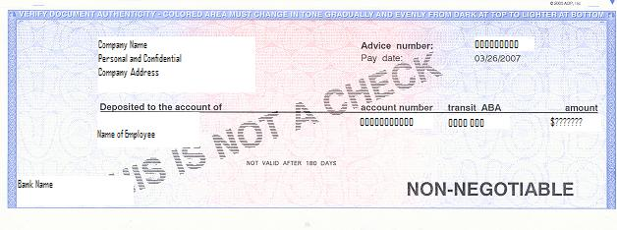



**Account Number**

**Transit Number**

**Employee Name**

**Amount**

**Employer Name/Employer Address**

**Date**

TAX & Employment FORMS

Even before you start working you will need to fill out certain paperwork for your employer some of which is related to taxes. Be sure to bring required documentation such as a passport or your school or state ID or driver’s license AND your social security card or birth certificate to your orientation or your first day of work. You will generally have to complete an **I9** to verify you are eligible for employment & a **W4** regarding your tax withholding when you are hired.

In order to complete your tax and employment forms, you will also need to know your **dependency status** or if anyone else claims you on their tax return and if you owed taxes in the past year. (If you think you are falsely claimed on someone’s taxes, contact your instructor or see the resource guide for help.)

You will likely receive a **W2** later in the year and may need to complete a tax return so be sure to keep all your employment records & pay stubs.

Learn more at **LRNG-OSC.org. Select Be Pay Day Ready – Tax Ready**.

*(There is also information included on LRNG-OSC.org for youth who are independent contractors & receive stipends. They may receive a 1099 & will not have taxes withheld. This means they will need to save funds to pay these later.)*

Where did all my money go?

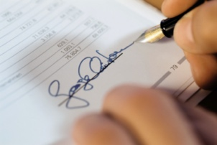Jessie earned $110.40 for his part-time tutoring position, but his paycheck was only written for $105.35.

What happened to the rest of Jessie’s money?

TAXES! TAXES!

**Taxes are money charged by the government to cover the costs of things like your police, fire department, schools, the armed forces, etc. Employers ARE REQUIRED to take taxes out of an employee’s paycheck.**

**Even if you do not make enough money to pay federal &/or state income tax, you will have to pay Medicare & Social Security or Payroll/FICA tax. Learn more at LRNG.org/Chicago – Be Pay Day Ready (Tax) prior to your first day of work.**

**EXAMPLE:** From Jessie’s paycheck, a total of $1.74 went to Medicare taxes (to cover health insurance for low-income individuals) and $3.31 went to taxes for the state.

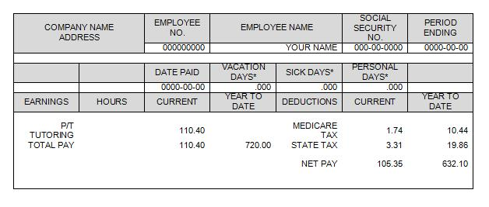**Find both items below and circle them.**

**DEAR DICTIONARY**

**Gross Pay** = Total pay before deductions for any taxes or health insurance costs

**Net Pay** = Pay after any deductions

Because Jessie’s paycheck was so small, the tax that he owed the federal government was not taken out of his paycheck. However, he may owe taxes later.

|  |  |  |
| --- | --- | --- |
| **Sample 2017 Federal Income Tax Rates\*** | | |
| **Taxable Income** |  | **Rate** |
| $0 - $9,525 |  | 10% |
| $9,525 - $38,700 |  | 15% |
| $38,700 to $93,700 |  | 25% |
| $93,700 to $195,450 |  | 28% |
| $195,450 to $424,950 |  | 33% |
| $424,950 to $426,700 |  | 35% |
| $426,700 |  | 39.6% |

If Jessie earned more, $700 per month or $8,400 per year, **using the sample 2017 income tax chart to the right, what would Jessie’s federal income tax bracket be? ____.**

**What if Jessie gets a raise and goes over the tax bracket limit of $9,525 by $1,000, what portion (or percent) would Jessie owe on any money over the tax bracket limit? ____**

**You won’t get to take ALL of your paycheck home.**

**Don’t plan to spend it ALL!**

*See irs.gov for updated rates

**Individuals are sometimes eligible to receive tax credits and/or free tax preparation depending upon income. Find a VITA site and learn more at** [**www.IRS.gov**](http://www.IRS.gov) **- Search VITA.**

WHAT SHOULD I DO WITH MY PAYCHECK?

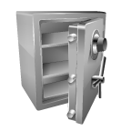**It is best to open a bank account (see Ch 4) and take your paycheck to your bank where you can deposit your paycheck for little or no fees.** Depositing some or all or your paycheck in the bank ensures that your **money will be safe, and you may earn extra money, called interest (see definition below) (SEE PAGE 27 FOR A LESSON ON OPENING AN ACCOUNT.)**

How do I cash **or deposit** my check?

To cash or deposit your check, you must sign it. You sign checks above the line on the back of the check. (Try signing a check on the example below.)

**DEAR DICTIONARY**

**What is a …?**

**BANK ACCOUNT** = an account or fund at a bank in which you keep your money

**DEPOSIT** = to put money in a bank account

**WITHDRAW** = to take money out of your bank account

**CASHING A CHECK** = to exchange or sign over a check in your name for cash

**INTEREST** = a small amount of money that the bank gives you in return for keeping your money there

**ALWAYS sign your check in INK and try to use the same signature.**

Banks will ask for identification if you are going to cash a check or ask for money back in cash when you make a deposit. **BRING YOUR STATE ID OR DRIVERS LICENSE!**

**Sign here.**

 **Practice signing a paycheck!**

**PEOPLE without bank accounts often spend $400 per year on check cashing costs and other bank fees alone!**

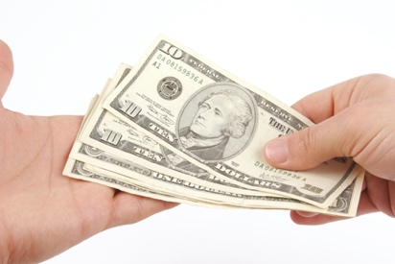

In the Chicago area, visit GetBankedChicago.com to learn more about how **BANKING CAN PAY OFF FOR YOU!** Learn more about high quality bank accounts in your area.

You can also **VISIT LRNG-OSC.org & select Be Pay Day Ready** to complete education activities & access to new opportunities such as scholarship competitions.

Some banks can allow you to use **mobile deposit** or deposit your check via your phone. This is very efficient and helps many people to save securely. Remember, IF you DO this, your check HAS been deposited and CANNOT be cashed or deposited again!

BANK TO AVOID PAYDAY LOANS

Payday loans may seem like a quick fix. However, they can end up costing you hundreds of dollars or more! **The effective annual percentage rate (APR) or rate of interest per year on pay day loans in some states can be as much as 400%.**

**Dear Dictionary …**

**Interest** = Money charged to a borrower by a lender for the use of the lender’s money

*(Interest is calculated as a % of principal.)*

That means if you borrowed $100 (your **principal**) each pay period, your **interest** and fees calculated over the course of the year would end up costing you $400 in charges!

400% INTEREST?!

NO WAY!

**BE YOUR OWN BANK! SAVE MONEY IN AN EMERGENCY FUND TO AVOID THE NEED FOR PAYDAY LOANS DOWN THE ROAD!**

what else should i do with my paycheck?

Why does saving and investing matter when I don’t make much money yet?

*"My dad said his dad just kept his money under a mattress all those years but …what if the house burned down, what if there was a robbery, that’s just not safe …just know that your money is always protected in the bank.”*

Jill, College Student, Intern



A little can go a long way! How much do you need to Invest each day to be a millionaire when you retire?

**Only $7.50 per day[1]!**

Have a job? Save some of the money that you earn - even at minimum wage - and you will be on your way to building a saving habit and having money to invest in the future!

**Your summer job could be your start on the track to becoming a millionare! Save first!**





**Why should I consider Direct Deposit?**

1) **Security** = Your check will not be lost or stolen as your money is put DIRECTLY and safely into your bank account.

2) **Free** = There is generally no charge for direct deposit so you will avoid check cashing fees!

3) **Convenience** = You will not waste time going to the bank to make your deposit.

4) **Speed** = You will get your money faster as funds are usually available the morning of your payday vs. checks that take 1-2 days.

5) **Reliability** = Regulations require that your funds will be deposited correctly and on time.

6) **Savings commitment** = It is easier to meet your savings goal using direct deposit. There is less temptation to convert your check into cash and spend it.

Do you have trouble saving? Make it automatic!

**USE DIRECT DEPOSIT! Start automatically depositing some of your paycheck into a savings account.**

*"... I actually have an automatic savings thing where it puts money into my savings account automatically.”*

Evan, Young Adult

What is direct deposit?

**Account Number** = this # identifies your specific account. *(Think of this like your specific street address & apartment #.)*

**Routing Number/Bank Transit ABA Number** = this # identifies your bank. *(Think of this like your city’s zip code on your address.)*

Direct deposit allows your paycheck to be automatically deposited in your bank account electronically.

How does it work?

Direct deposit is similar to the process used when depositing a check in person. Funds are directed by an **account number** and a **routing number**. However, with direct deposit, the funds are **sent electronically** to your bank from the organization that is paying you through the **National Automated Clearinghouse (ACH)** system. The Federal Reserve Banks and financial institutions process these requests.

Signing Up for Direct Deposit

What is the **National Automated Clearinghouse (ACH)** System?

An electronic network for [financial transactions](http://en.wikipedia.org/wiki/Financial_transactions) in the United States.

The largest operator of the ACH is the Federal Reserve Banks. In 2011, this network processed 20.2 billion ACH transactions with a total transaction value of $33.91 trillion.

When you sign up for direct deposit, your employer will ask you for your bank account information (routing number, account number, etc.) so they will know where to deposit your money.

Is direct deposit really safe?

Yes! Over 30 million people use direct deposit. Of the 1 billion deposits in 1992, 99.9% were executed perfectly. Of the 0.1% that had errors, almost all of these were fixed within one day. (There are government regulations that require errors to be fixed in one day or investigated.)



*“The first time I did the internship I did not have direct deposit and I ended up spending all my money. When I got direct deposit, I was like …I have the control I need. I can save... I got through my first and second semester of college off [the earnings from] one internship …”*

Blake, College Student - Intern

direct deposit practice

Jessie wants to set up direct deposit. He would like to have 50% of his paycheck deposited in his checking account and 50% deposited in his savings account. His savings account # = 2345678901 and his checking account # = 1234567890. His bank name is “The Best Bank”. His bank routing # = 987654321.

Complete the sample authorization below for Jessie.

SAMPLE AUTHORIZATION AGREEMENT FOR AUTOMATIC DIRECT DEPOSITS

Real World Translation = *I agree that my employer can pay me in the accounts I list below. If they deposit or pay too much accidently, they can take back what they accidently deposited.*

**Company** = Employer or organization paying you

**Depository** = Your bank or other financial institution

I hereby authorize "**Company**", to initiate credit entries for sums to and payable to me to my checking, savings or other account indicated below; and the Financial Institution named below, hereafter called **"Depository"**, to credit the same to such account. I also authorize Company to initiate debits for sums due to the Company for erroneous deposit or deposits at the Depository.

Bank Name: Best Bank Routing/Bank Transit ABA No: 987654321

Bank Account No.: Amount or Percent

Checking: 1234567890 50%

Savings: 2345678901 50%

Other:

This authorization is to remain in full force and effect until Company has received notification from me of its termination in such time and in such manner as to afford Company a reasonable opportunity to act on notification or until such time as Company terminates this agreement.

Employee Name: Jessie Doe

Employee Signature: *Jessie Doe*

Date: ??/??/????

Paycheck jeopardy: you’re in the money!

* Question: The best thing to do with your paycheck is to deposit it in a bank_ _ to AVOID check cashing fees.
* Question: Currency exchanges will cash your paycheck, but they charge check cashing fees.
* Question: A bank_ loan is generally less expensive than a payday loan that can sometimes charge up to 400% interest.
* Question: One of the easiest ways to save is to have part or all of your paycheck deposited automatically. This is called direct_ deposit.
* Question: Employers ARE REQUIRED to take taxes_ out of an employee’s paycheck.

bank



*A journey of a thousand miles begins with one step.*

Lao Tzu, Chinese Philosopher

***A savings of $1,000,000 starts with one dollar!***

1. Assumes a 7.5% annual return on average over 49 years.

  