


College Financing
6

Paying
for College

Worried about paying for college?

Worried about paying for college or training classes after high school?
You are not alone! College debt recently exceeded credit card debt as the largest non-mortgage (or non-home loan) debt in the United States.

The average college student now graduates with $30,000 in debt!

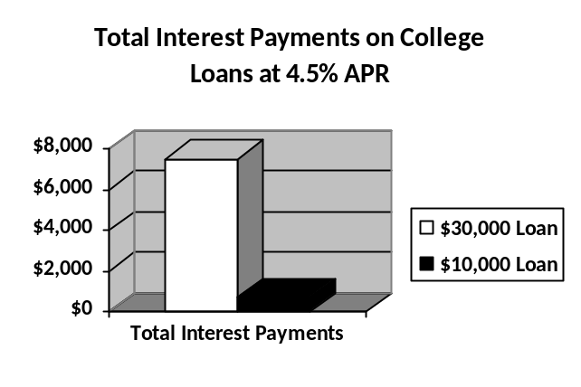If that is not bad enough, let’s look at the total cost of that loan with interest. If you had $30,000 in debt, at a 4.5% interest rate with $300 monthly payments, you would be paying this debt for 10 years and end up paying $7,500 in interest!

What if you could reduce your debt to $10,000 by obtaining more scholarships, selecting more affordable options or obtaining work/study? This would cut your interest costs to just $700 over 3 years!

College costs are high but the cost of NOT going to college is MUCH higher! Average graduates make over $1,000,000 more over their lifetime than non-graduates. (See page 6) That’s much more than the average $30,000 loan!

College is worth it! Be smart in choosing and paying for college!

what do you need to know to reduce your costs?
DEAR DICTIONARY: Scholarships/ Grants vs. Loans:
What is the Difference?

SCHOLARSHIP/GRANT = A sum of money given to support a student’s academic pursuits

LOAN = A sum of money that is borrowed and expected to be paid back with interest

INTEREST = Extra funds charged to a borrower for the benefit of using the lenders money

BOTTOM LINE: SCHOLARSHIP/GRANTS ARE FREE – LOANS MUST BE PAID BACK WITH INTEREST

WORK STUDY = A program in place in many colleges that lets students hold part-time jobs while in school in order to subsidize the cost of education

UNMET NEED = Unmet need refers to expected costs that will need to be paid AND are still left after all financial aid (grants, scholarships, loans, work study) has been offered

BOTTOM LINE: BE CAREFUL OF ‘UNMET NEED’! PLAN AHEAD! YOU WILL HAVE TO COME UP WITH THESE FUNDS SOMEHOW!

DEAR DICTIONARY: SUBSIDIZED VS. unsubsidized loans:
What is the Difference?

SUBSIDIZED LOANS = Generally based on your financial need, interest on these loans is typically paid by the government during college (check into specific requirements for course load hours, etc.)

UNSUBSIDIZED LOANS = Not based on your financial need, interest grows or accrues during college. (Interest can sometimes be deferred, or payments can be delayed until after college but the student is responsible for the interest costs even from the time period during college.)

How do I know how much is too much to borrow?

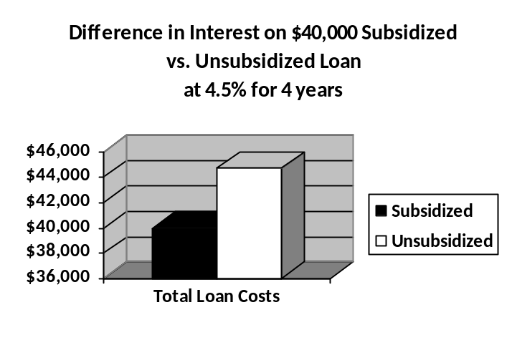
Obtaining Unsubsidized vs. Subsidized Loans Matters!

If you have an unsubsidized loan for $10,000 each year for 4 years of college, your loan will generate $4,700 in interest over these 4 years. If you obtained a subsidized loan, the government will pay your interest saving you - $4,700!

How can I save on college costs?


- Start searching for scholarships EARLY and try MANY scholarship sources! Small or less well-known scholarships can sometimes be much easier to win and have fewer applicants than more well-known scholarships.
  - Think about YOUR unique talents or interests. There are often scholarships for your specific major, your college or for certain clubs or service-learning experiences you may have obtained.
  - Just completing financial literacy in Countdown to 21, setting a savings goal with Young Illinois Saves or completing the LRNG Be Pay Day Ready learning modules at LRNG-OSC.org qualifies you to apply for our scholarship competitions.
- Fill out the FAFSA as soon as it becomes available. Learn more at FAFSA.gov! This is a critical step! The early bird gets the worm with this one. The date you apply matters. Gather as much information as you can in advance. (Students with name changes or lost identification records have had challenges in the past.)
- Consider work-study! With work-study (see definition on previous page), students can help earn funds to pay for college on campus. Jobs are often more flexible with students’ schedules and can also help you build your resume. However, if you receive notification of work-study on your award letter, be sure to find out how to apply for these on campus. Work-study can be competitive, and a position is generally not guaranteed!
- After seeking grants, scholarships and work study opportunities, look for subsidized student loans next. (See definitions and graph highlighting cost savings on page 47.) Then consider unsubsidized student loans. (Even unsubsidized loans are more cost effective than having to turn to options like credit cards for funds.)
- Carefully review your award letters and consider your options.
  - Be sure to consider the overall cost of each college option and especially any money you must borrow! Less expensive options such as in-state colleges or spending 2 years at community college, saves many students thousands of dollars! Consider which college option is the best fit for YOU!
- Make a budget for college at CollegeBudgetBuilder.org! Be sure to manage your financial aid well, keep your grades up and complete any other requirements for scholarships, aid and work study.
Rule of Thumb:
A general rule of thumb is that total debt for college should not exceed the student’s expected annual salary during the first year following graduation.
FINANCIAL AID jeopardy: PAYING FOR COLLEGE!

- Question: To have the most access to funds for college complete the FAFSA_ early!

- Question: A scholarship is a sum of money that a student is given to pay for college that they do NOT need to pay back.

- Question: College loans must be paid back with interest (or extra money a borrower must pay to a lender for the benefit of getting the loan).

- Question: A subsidized college loan must be paid back BUT the government generally pays the interest on the loan while you are in college.

Need help?

Visit these sources to learn more about paying for college and get answers to your scholarship & loan questions!

United States Department of Education, www.studentaid.ed.gov
& www.FAFSA.ed.gov

Illinois Student Assistance Commission, www.isac.org
(Access one-on-one help in Illinois here!)

